**Description**

As a user I must have ability to view Store Info.

As a user I should have ability to navigate to Contact info when clicked on “Contact us”.

------------------------------------------------------------------------------------------------------------------------------------------

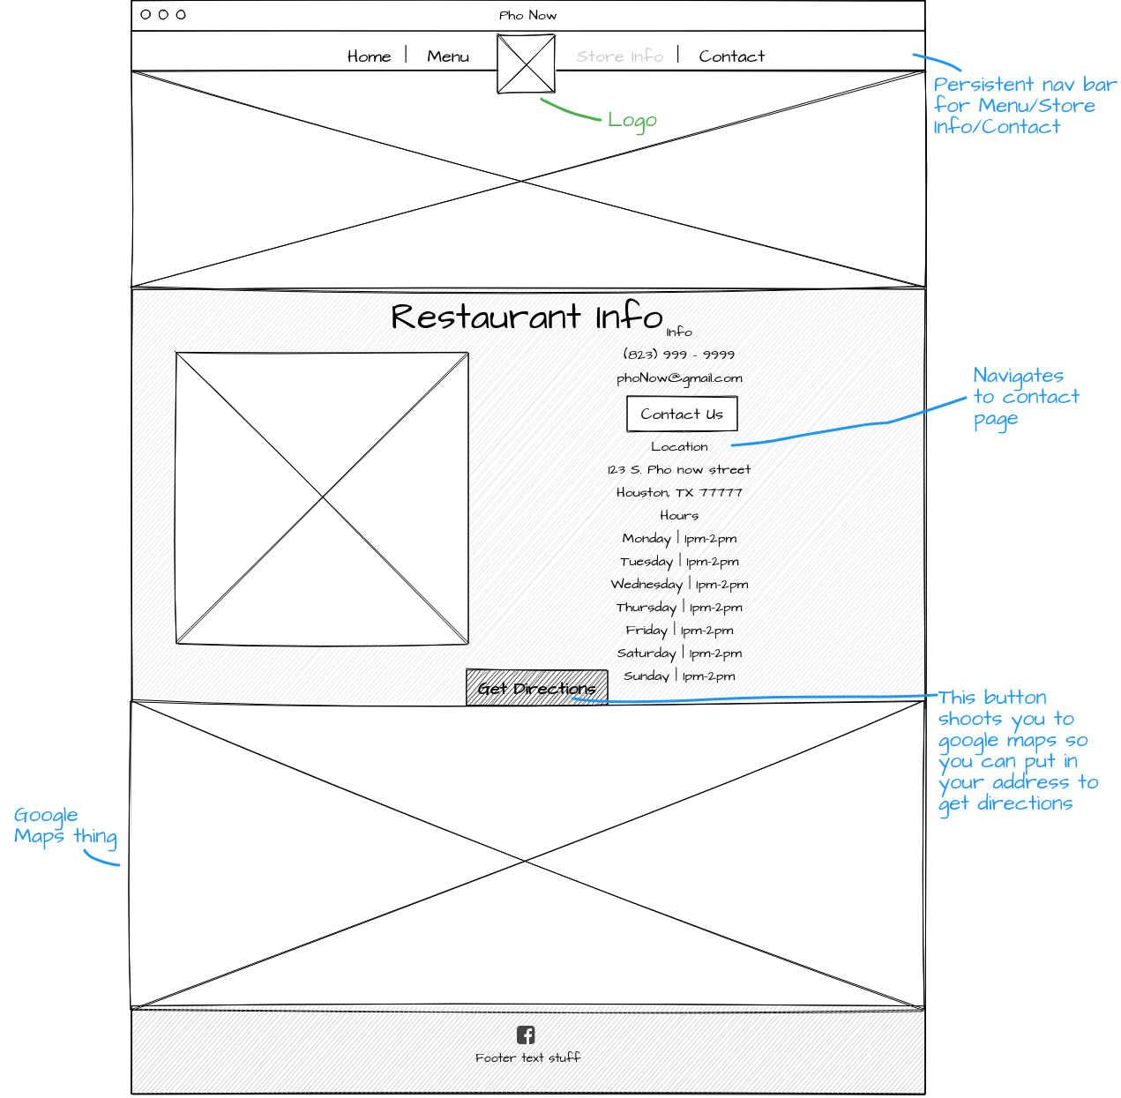

**Acceptance criteria**

* Display restaurant logo.
* Display Phone number
* Display email address
* Display address.
* Display Hours of operation
* Display Location link